# Lab 2

## Conditionals and Loops

Skills Required

* Loops (while, for)
* Conditional (if, switch)
* Datatypes, assignment, etc.

Requirements

* You must use constants for the ticket prices for each group
* You must use at least one if else
* You must use a switch statement conditional

1. Create a new project in Visual Studio 2019 like you did in the last lab.
   1. Create a Lab02.cpp in source files.
   2. Remember to include iostream. Including string may also be helpful.
2. Assignment

This fun park ticket sale calculator will output ticket sales for 3 days.

Each day the employee can enter ticket sales for (C)hildren, (A)dults, (S)eniors, and (V)IPs or they can (Q)uit to end the day. The system will ask for how many of that type, and keep track of the total for that day. Once the user enters Q, then the totals for the day are calculated and output for each ticket group.

Table TicketPrices

|  |  |
| --- | --- |
| Group | Price |
| Children | 10.95 |
| Adults | 19.99 |
| Seniors | 18.99 |
| VIP | 7.99 |

The user can choose any category more than once, in which case the # in that category will be added. For example, the user may choose adults and enter 3 adults, and then later the same day choose the adults category again and add 5 more adults, bringing our adults total for the day to 8.

You may find it helpful to use the toupper() function.

char example = 'a';

char upperExample;

upperExample = toupper(example);

Total Ticket sales after 3 days will be output before the program exists.

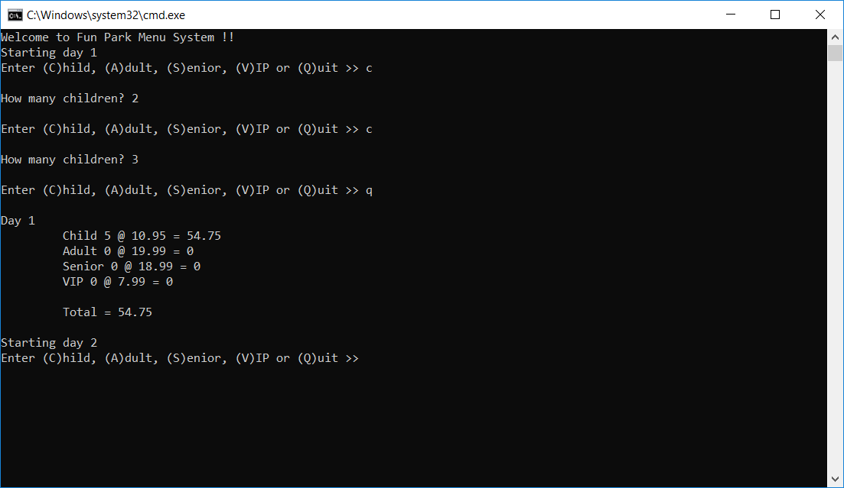

Output Window 1

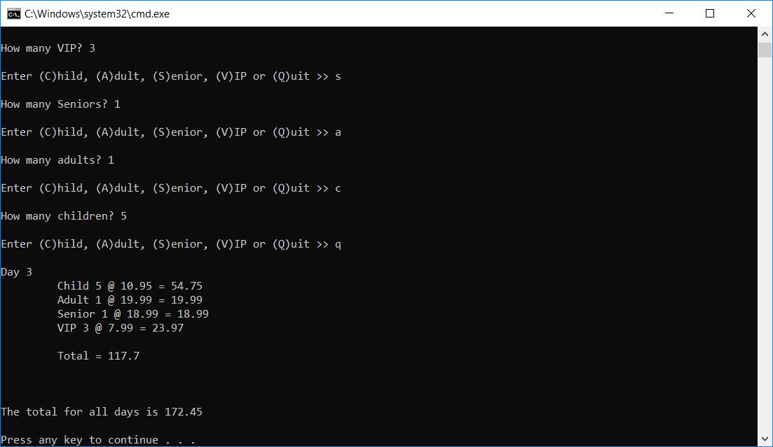

Output Window 2

1. Save all files, delete the contents of the Debug directory, and upload your submission to Canvas.